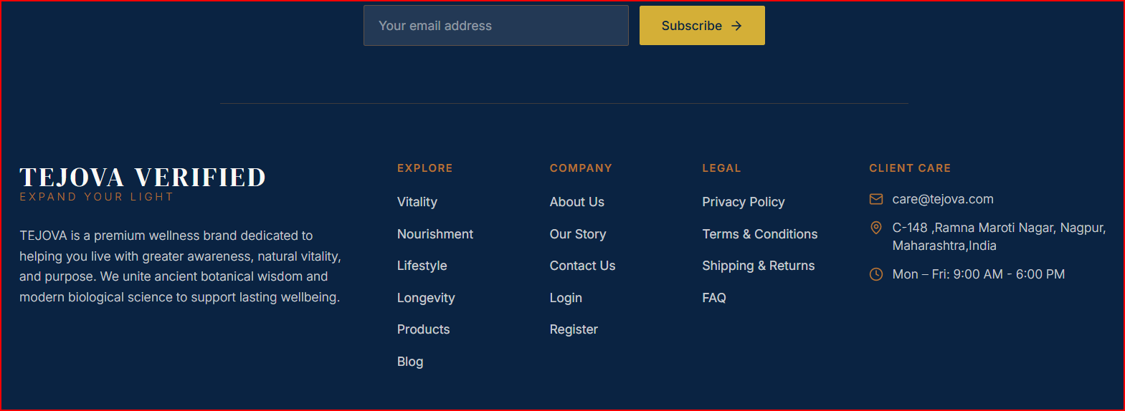
Add the data as mentioned below and activate all the points, please check at your end.
Privacy Policy
Effective Date: 07.11.2026, Website: www.tejova.comCompany: Tejova Life
At Tejova Life ("Tejova," "we," "us," or "our"), we are committed to protecting the privacy, security, and Biological Sovereignty of our clients. This Privacy Policy governs how we collect, use, process, and protect your personal and health-related data when you visit our website (tejova.com), engage with our digital platforms, or participate in the Tejova Protocols and private consultations.
This policy is designed to comply with global data protection standards, including the Digital Personal Data Protection Act (DPDPA, India), the General Data Protection Regulation (GDPR, EU/UK), and the California Consumer Privacy Act (CCPA, USA).
1. The Information We Collect
To engineer your personalized health architecture, we must collect specific categories of data. We strictly limit collection to what is necessary for your care and our service delivery.
- Identity & Contact Data: Name, email address, phone number, billing/shipping address, and demographic information required to establish your profile.
- Sensitive Biological & Health Data: Information provided during consultations, including medical history, lifestyle habits, sleep rhythms, dietary preferences, metabolic markers, and any physiological data required to design your Bespoke Metabolic & Diet Protocols. (Note: This is collected only with your explicit, informed consent).
- Financial & Transaction Data: Details about payments and services purchased. (Payment processing is handled securely by encrypted, third-party payment gateways; we do not store your full credit card or bank details on our servers).
- Technical & Usage Data: IP address, browser type, time zone setting, operating system, and data on how you interact with our website to ensure a seamless digital experience.
2. How We Use Your Data
We utilize your data solely to elevate your health and provide a seamless executive experience. We use your information to:
- Deliver, design, and manage the Tejova Protocols and 1-on-1 consultations.
- Provide ongoing concierge support and adapt your nutritional and lifestyle architecture.
- Process secure transactions and manage your account.
- Communicate with you regarding appointments, protocol updates, and secure health insights.
- Comply with legal, regulatory, and medical record-keeping obligations.
3. Legal Basis for Processing (GDPR & Global Standards)
Under international data protection laws, we process your personal data based on the following legal grounds:
- Explicit Consent: When you provide sensitive biological and health data for our consultation services. You may withdraw this consent at any time.
- Contractual Necessity: To fulfill our service agreements, process your payments, and deliver the Tejova Protocols you have requested.
- Legitimate Interests: To secure our digital infrastructure, improve our website, and prevent fraud.
- Legal Obligation: To comply with applicable financial and medical compliance laws in India and internationally.
4. Data Sharing and Third Parties
Your biological data is treated with the highest level of confidentiality. We do not and will never sell your personal or health data to third parties.
We may share your data only in the following restricted circumstances:
- Trusted Service Providers: With carefully vetted third-party vendors who assist us in operating our platform (e.g., secure cloud hosting via Hostinger, encrypted video consultation platforms, and payment processors). These providers are legally bound by strict data processing agreements.
- Legal & Regulatory Authorities: If required to do so by law, court order, or regulatory mandate to protect the rights, property, or safety of Tejova Life, our clients, or the public.
5. International Data Transfers
Tejova Life operates its foundational base in Nagpur, Maharashtra, India. If you are accessing our services from the European Economic Area (EEA), the United States, or other regions, your data will be transferred to and processed in India. We ensure that all international data transfers comply with global standards by utilizing Standard Contractual Clauses (SCCs) and ensuring our hosting and software partners maintain GDPR-compliant security frameworks.
6. Data Security and Retention
We implement robust, industry-standard cryptographic and physical security measures to protect your data against unauthorized access, alteration, or disclosure. We retain your personal and biological data only for as long as necessary to fulfill the purposes outlined in this policy, deliver your ongoing health protocols, or comply with mandatory legal retention periods.
7. Your Privacy Rights (Sovereignty over your Data)
Depending on your jurisdiction (including DPDP Act, GDPR, and CCPA), you hold the following rights regarding your data:
- The Right to Access: You may request a copy of the personal and biological data we hold about you.
- The Right to Rectification: You may request that we correct any inaccurate or incomplete information.
- The Right to Erasure ("Right to be Forgotten"): You may request the deletion of your personal data, subject to certain legal and medical record-keeping exceptions.
- The Right to Restrict/Object: You may object to how we process your data, particularly for marketing purposes.
- The Right to Data Portability: You may request your data be transferred to another provider in a structured, commonly used format.
- The Right to Withdraw Consent: Where we rely on consent to process your health data, you can withdraw it at any time (though this may prevent us from continuing to provide bespoke health protocols).
To exercise any of these rights, please contact us using the details below.
8. Cookies and Tracking Technologies
Our website uses cookies and similar tracking technologies to ensure optimal performance, analyze site traffic, and enhance your user experience. You can manage your cookie preferences through your browser settings. A detailed breakdown can be found in our standalone [Cookie Policy - link to be added].
9. Policy Updates
As our ecosystem evolves, we may update this Privacy Policy to reflect changes in legal requirements or our operational practices. We will notify you of any significant changes by posting the new policy on this page and updating the "Effective Date."
10. Contact Us
For any questions, concerns, or requests regarding this Privacy Policy or the security of your data, please contact our Data Protection Officer at:
Tejova Life Email: concierge@tejova.com, Address: C-148, Ramana Maroti Nagar, Nagpur, Maharashtra - 440024, India

Terms and Conditions of Service
Effective Date: 07.11.2026 Website: www.tejova.comCompany: Tejova Life
Welcome to Tejova Life. These Terms and Conditions ("Terms") govern your access to and use of the Tejova.com website, digital platforms, educational materials, and the Tejova Protocols (collectively, the "Services"). By accessing our platform, booking a consultation, or purchasing our digital products, you agree to be bound by these Terms.
1. The Tejova Ecosystem and Scope of Services
Tejova Life operates as a premier digital and in-person practice specializing in evidence-based nutritional science, restorative naturopathy, and holistic health optimization. Our offerings include, but are not limited to:
- Bespoke Metabolic & Diet Protocols
- 1-on-1 Executive Consultations (Online and Offline)
- Yoga and Structural Resilience guidance
- Digital publications and educational materials (including e-books)
2. Strict Medical Disclaimer (Assumption of Risk)
Tejova Life provides architectural blueprints for health optimization, not medical treatment.
- The services, protocols, and content provided Archana C Parate, and the Tejova Research & Practice Group are for educational and structural health optimization purposes only.
- We are certified practitioners in nutrition and naturopathy; we are not licensed medical doctors (MDs).
- Our guidance, including dietary recommendations, natural regimens, and lifestyle architecture, does not constitute medical advice, diagnosis, treatment, or a cure for any specific medical condition or disease.
- You must consult with a licensed primary care physician before beginning any Tejova Protocol, altering your diet, engaging in physical regimens, or modifying any prescribed medications. You assume total responsibility and risk for your voluntary participation in our programs.
3. Client Sovereignty and Responsibilities
To engineer an accurate and highly personalized protocol, we require your complete transparency. By engaging our services, you agree to:
- Provide accurate, current, and complete information regarding your physical health, biological markers, and lifestyle habits during consultations.
- Understand that absolute health transformation requires your active participation, discipline, and consistent application of the prescribed daily rhythms.
- Acknowledge that biological responses vary by individual, and Tejova Life cannot guarantee specific physical, metabolic, or cognitive results.
4. Intellectual Property and Brand Protection
The architecture of Tejova is proprietary. All content on Tejova.com—including text, graphics, logos, brand names ("Tejova," "Tejova Life," "Expand Your Light"), protocol frameworks, website design, and published digital materials (such as the e-book 21 Daily Habits for Lifelong Health)—is the exclusive intellectual property of Tejova Life and is protected by Indian and international copyright and trademark laws.
- You are granted a limited, non-exclusive, non-transferable license to access our digital content and utilize your personalized protocols for personal, non-commercial use only.
- You may not reproduce, distribute, modify, create derivative works of, publicly display, or commercially exploit any Tejova Life content or protocol frameworks without our explicit, written consent.
5. Payments, Digital Commerce, and Refund Policy
All financial transactions for consultations and digital products are processed through secure, third-party payment gateways integrated into our platform.
- Consultations: Fees for online and offline 1-on-1 consultations must be paid in full prior to the scheduled session. Rescheduling or cancellation requests must be made at least 24 hours in advance. Failure to attend a scheduled session without prior notice may result in the forfeiture of the consultation fee.
- Digital Products (E-books & Guides): Due to the immediate, downloadable nature of digital information products, all sales of e-books and digital frameworks are final and non-refundable.
- Pricing: We reserve the right to modify the pricing of our protocols, consultations, and products at any time without prior notice.
6. Platform Usage and Security
You agree to use Tejova.com only for lawful purposes. You are strictly prohibited from:
- Attempting to breach the security of the platform, host, or network.
- Using automated systems (data mining, scraping, robots) to extract proprietary information from the website.
- Submitting false, malicious, or technologically harmful material (such as viruses or malware).
7. Limitation of Liability
To the maximum extent permitted by applicable law, Tejova Life, its founders, and practitioners shall not be liable for any direct, indirect, incidental, consequential, or punitive damages arising out of:
- Your use of, or inability to use, the Tejova.com platform or services.
- Any physical, biological, or psychological outcomes resulting from the implementation of our nutritional or lifestyle protocols.
- Errors, omissions, or inaccuracies in any content provided on the website or within digital products.
8. Governing Law and Dispute Resolution
These Terms and Conditions, and any separate agreements whereby we provide you services, shall be governed by and construed in accordance with the laws of India. Any disputes, claims, or legal proceedings arising out of or relating to these Terms or the Tejova ecosystem shall be subject to the exclusive jurisdiction of the courts located in Nagpur, Maharashtra, India.
9. Modifications to the Terms of Service
Tejova Life reserves the right to update, change, or replace any part of these Terms at our sole discretion. It is your responsibility to check this page periodically for changes. Your continued use of or access to the website and our services following the posting of any changes constitutes acceptance of those changes.
10. Contact Information
For inquiries regarding these Terms and Conditions, or to seek clarification on our protocols and policies, please direct your communication to:
Tejova Life Email: concierge@tejova.com, Address: C-148, Ramana Maroti Nagar, Nagpur, Maharashtra - 440024, India

Shipping, Delivery, and Refund Policy
Effective Date: 07.11.2026 Website: www.tejova.comCompany: Tejova Life
At Tejova Life, we value absolute clarity, precision, and the mutual respect of time. This policy outlines the operational guidelines for the delivery of our digital protocols, the scheduling of our executive consultations, the shipping of any physical materials, and our authoritative stance on returns and refunds.
1. Digital Delivery & Access (E-Books & Protocols)
The Tejova ecosystem relies heavily on immediate, high-impact digital delivery to ensure you can begin architecting your health without delay.
- E-Books & Digital Guides: Upon successful payment processing for digital products, including 21 Daily Habits for Lifelong Health: Your Practical Guide to Natural Wellness, you will receive an automated email containing a secure download link or immediate portal access. Delivery is instantaneous.
- Customized Diet & Metabolic Protocols: For clients engaging in 1-on-1 consultations, your bespoke architectural blueprints (digital protocols) will be delivered to your registered email address within 48 to 72 hours following the conclusion of your clinical assessment.
- Technical Issues: If you experience any technical friction or do not receive your digital access link within 60 minutes of purchase, please contact our support desk immediately at care@tejova.com for priority resolution.
2. Consultation Scheduling, Rescheduling, and Cancellations
Time is the ultimate executive asset. We enforce strict boundaries to protect both your schedule and the dedicated focus of the Tejova Research & Practice Group.
- Confirmation: All consultations (both virtual and at our Nagpur center) are confirmed only upon receipt of full payment.
- Rescheduling & Cancellations: You may reschedule or cancel your consultation without penalty if notice is provided at least 24 hours prior to the scheduled session time.
- Late Cancellations & No-Shows: Cancellations made within the 24-hour window, or failure to attend a scheduled session, will result in the total forfeiture of the consultation fee. Our practitioners allocate highly focused time for your biological assessment, which cannot be reassigned at the last minute.
3. Physical Shipping Policy (If Applicable)
Should you purchase physical goods, printed publications, or botanical materials directly from Tejova Life, the following logistical parameters apply:
- Dispatch & Processing: Physical orders are processed and dispatched from our foundational base in Nagpur, Maharashtra, within 2 to 3 business days of order confirmation.
- Domestic Shipping (India): We utilize premium logistics partners. Standard delivery within India takes approximately 4 to 7 business days post-dispatch, depending on your regional location.
- International Shipping: Global transit times vary by destination (typically 10 to 21 business days). International clients are solely responsible for any customs duties, import taxes, or localized levies applied by their respective regulatory authorities.
- Tracking: A secure tracking number will be provided via email the moment your physical asset is handed over to our courier partner.
4. Returns & Refund Policy
Due to the proprietary nature of our intellectual property and the highly customized design of our biological frameworks, our refund policies are strictly enforced.
- Digital Products (Strict Non-Refundable Policy): Given the immediate, un-retractable nature of downloadable information, all sales of e-books, digital guides, and pre-recorded digital content are final. No refunds, exchanges, or credits will be issued under any circumstances.
- Consultation Fees: Refunds for consultations are only granted if the cancellation is requested outside the mandatory 24-hour window prior to the appointment. Once a consultation has been conducted, the fee is entirely non-refundable, as the service and clinical time have been rendered.
- Physical Goods: If you receive a physically damaged or defective item, you must notify us within 48 hours of delivery with photographic evidence. Upon verification, Tejova Life will issue a replacement or authorize a return. We do not accept returns for physical goods based on "change of mind."
5. Grievance and Support Contact
To request a schedule adjustment, report a digital delivery failure, or raise a logistical inquiry, please direct your communication to our operations desk. We ensure priority handling for all active clients.
Tejova Life Operations Email: [Insert Official Email Address, e.g., concierge@tejova.com, Address: C-148, Ramana Maroti Nagar, Nagpur, Maharashtra - 440024, India

FAQ:
1. Does the Tejova nutritional protocol require a specific regional cuisine or strictly Indian foods? No. Biology is universal. While our foundational base is in India, our protocols are rooted in global metabolic science and cellular architecture. Whether you reside in New York, London, or Mumbai, we design your bespoke dietary protocol around the high-quality, plant-aligned foods native to and accessible in your specific geographical location. We focus on the glycemic load and nutritional density of your meals, adapting our nature-based principles to your culture and executive lifestyle.
2. Are your diet plans based on calorie counting or restrictive macro-tracking? We reject tedious calorie counting and algorithmic biohacking. High-functioning leaders do not have the time or decision capital for disjointed, restrictive tracking. Instead, our protocols focus on metabolic rest and time-restricted eating. We architect a rhythm of nourishment that naturally stabilizes your blood sugar, honors your chronobiology, and fuels cellular regeneration without adding daily friction to your schedule.
3. I have a demanding global travel schedule. How do I maintain these dietary rhythms across different time zones? True Biological Sovereignty means your health does not collapse when your environment changes. We engineer your protocols with executive travel in mind. By teaching you how to strategically leverage time-restricted eating, hydration, and conscious elemental immersion, we help you anchor your circadian rhythm and defend your metabolic health, effectively insulating your physical vessel against jet lag and travel-induced systemic stress.
4. I have been informed that I have pre-diabetic markers. Is this protocol designed to address metabolic decline? Yes. Proactively defending against modern lifestyle diseases is the cornerstone of our Longevity pillar. Our evidence-based nutritional architecture is specifically designed to address metabolic decline at its root. Through pure, plant-aligned nourishment and precise eating windows, we aim to reverse the wear and tear caused by chronic stress, optimize body composition, and protect your long-term biological future. (Note: Tejova provides architectural blueprints for health optimization; our protocols should be implemented alongside the guidance of your primary medical physician).
5. Do the Tejova Protocols rely heavily on synthetic supplements and extreme clinical interventions? No. Led by Archana C Parate’s expertise in restorative naturopathy, we believe profound biological shifts come from consistent, natural rhythms, not extreme interventions. While highly targeted supplementation may be utilized for specific deficiencies, our primary mechanism for healing is pure, whole-food nourishment. We translate the theoretical frameworks of nature-based living into practical, daily executive action, prioritizing plant-aligned intelligence over synthetic shortcuts.
6. How exactly do the four pillars—Vitality, Nourishment, Lifestyle, and Longevity—work together in my diet? They operate as a single, unified ecosystem. Nourishment provides the raw, cellular building blocks and stabilizes your metabolic markers. This pure fuel directly ignites your baseline Vitality and cognitive stamina. We map this diet onto your executive Lifestyle using time-restricted eating and circadian alignment so it requires zero decision fatigue. Together, this unified approach proactively defends against lifestyle diseases, securing your ultimate Longevity and healthspan.
7. My schedule is incredibly demanding. Will implementing this protocol require a massive daily time commitment? No. The Tejova methodology is explicitly designed to eliminate friction, not add to it. We do not prescribe complex, hours-long meal prep or disjointed routines. Archana specializes in translating nature-based living into streamlined, time-efficient systems that integrate seamlessly into a high-pressure executive schedule. You are investing in efficiency—a unified protocol that frees up your decision capital rather than draining it.
8. What happens after I book a 1-on-1 private consultation? Once your consultation is secured, our practice group will conduct a deep, clinical assessment of your current metabolic state, lifestyle rhythms, and biological goals based on your provided medical reports. Following this session, Archana will engineer your bespoke architectural blueprint—a highly personalized metabolic and dietary protocol designed to fuel your cellular architecture. This protocol is delivered directly to you, accompanied by ongoing concierge support to ensure seamless integration into your life.

Contact us : Now Locked Open it and add the address

If any data added below found very long, then add it as suitable to website , I will edit and make it short

Vitality

1. Yoga
Sovereign Yoga
Decompress the spine and unlock structural mobility to reverse daily sedentary wear.
2. Breath
Autonomic Breath
Regulate your nervous system to instantly clear stress and restore focus.
3. Health
Cellular Health
Fuel natural cellular repair and metabolic rest to maximize your disease-free years.
4. Fitness
Adaptive Fitness
Build muscle, bone density, and vital stamina to ensure lifelong independence.

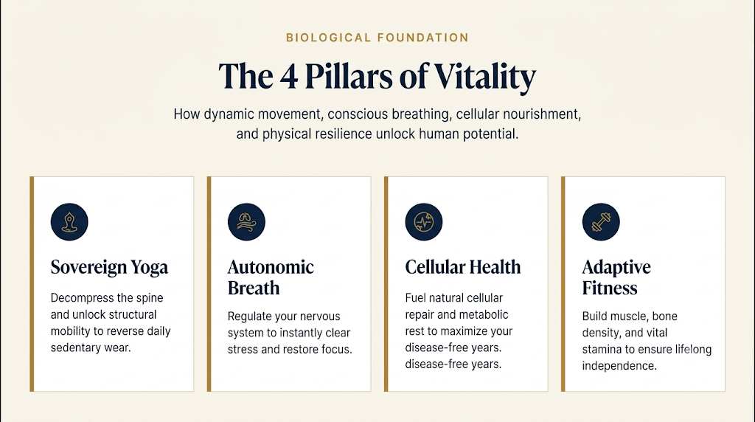

Lifestyle Pillars
- Cognitive Resilience
Actionable breathwork practices that shift nervous system arousal to immediately improve mental clarity.
- Circadian Alignment
Anchoring your internal biological clock to natural light cycles to optimize hormone secretion and eliminate chronic fatigue.
- Ecological Symbiosis Optimizing your internal biology through sustainable, eco-conscious daily habits.
- Collective Vitality Redefining longevity through shared community goals, collective joy, and deep relational belonging.
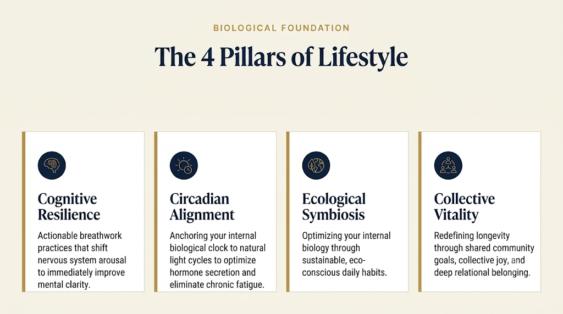

Longevity Pillars
1)Nutrition and Metabolic Health

Our protocol employs plant-aligned whole foods, time-restricted eating and proactive caloric control to repair your cellular architecture, sustain elite cognitive energy, and defend against lifestyle diseases.

2) Regeneration, Biological Aging, and Deep Recovery
Our recovery protocol balances deep regenerative rest with controlled environmental stress to repair your cellular architecture, build systemic resilience, and decelerate biological aging."

3) Psychological Coherence, Brain & Cognitive Longevity, and Autonomic Regulation
By discharging chronic stress and actively balancing your nervous system, we halt stress-induced aging and protect your lifelong brain health through a calm, regulated mind."

4) Socio-Environmental Connection and Purpose
Our longevity lifestyle extends your healthspan by removing isolation-induced aging through deep community connection, clear life goals and alignment with clean, natural environments.”


